**Lab Assignment 8**

|  |  |
| --- | --- |
| **Roll No.: A055** | **Name: Ibrahim Shaikh** |
| **Program: B. Tech**-**CSBS (2ND YEAR)** | **Date of Release: 20th September 2021** |
| **Batch:**  A/1 | **Date of Submission:** 3rd October 2021 |

**PROBLEM STATEMENT:**

**Problem Statement 1:** Assume that a bank maintains two kinds of accounts for customers, one called as savings and the other as current account. The savings account provides compound interest and withdrawal facilities but no cheque book facility. The current account provides cheque book facility but no interest. Current account holders should also maintain a minimum balance and if the balance falls below this level a service charge is imposed. Create a class account that stores customer name, account number and type of account. From this derive the classes cur_acct and sav_acct to make them more specific to their requirements. Include necessary member functions in order to achieve the following tasks:

(a) Accept the deposit from a customer and update the balance.

(b) Display the balance.

(c) Compute and deposit interest.

(d) Permit withdrawal and update the balance.

(e) Check for the minimum balance, impose penalty, necessary and update the balance.

**Concept Covered:** Inheritance and Class extension

**Problem Statement 2:** An educational institution wishes to maintain a database of its employees. The database is divided into a number of classes whose hierarchical relationships are shown in following figure. The figure also shows the minimum information required for each class. Specify all classes and define functions to create the database and retrieve individual information as and when required.

**Concept Covered:** Classes and Functions

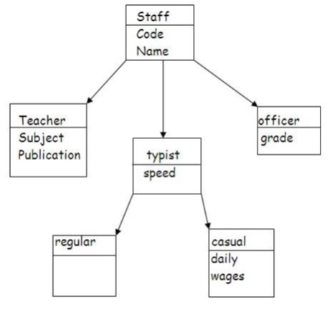

**CODE:**

**Code for Problem Statement 1**

#include<iostream>

#include<string.h>      //for string and strcpy

#include<math.h>        //for using 'pow' for power

using namespace std;

class Bank

{

    char cname[20];

    long int accno;

    string type;

    public:

    int bal;

    Bank()          //Default Constructor

    {

        strcpy(cname," ");

        accno=0;

        type=' ';

        bal=0;

    }

    void cdata()       //for Taking the Customer's Data

    {

        cout<<"Enter your Name: ";

        cin>>cname;

        cout<<"Enter your Account No. : ";

        cin>>accno;

        cout<<"Enter the type of your Account: ";

        cin>>type;

        cout<<"Enter the balance: ";

        cin>>bal;

    }

    void disp()     //for displaying the data

    {

        cout<<"\nCustomer Name: "<<cname;

        cout<<"\nAccount No. : "<<accno;

        cout<<"\nType of Account: "<<type;

        cout<<"\nBalance: "<<bal;

    }

    void deposit()      //for depositing money into their account

    {

        int a;

        cout<<"\n\nEnter the Amount of money to Deposit: ";

        cin>>a;

        bal+=a;

    }

};

class sav_acct:public Bank

{

    int i;

    public:

    int interest()      //for calculating the interest

    {

        int t, r = 10;

        cout<<"\nEnter time (in years) to calculate interest: ";

        cin>>t;

        i=bal*pow(1+r/100.0,t)-bal;

        return i;

    }

    int updatebal()     //for updating the balance after taking interest into account

    {

        bal=bal+i;

        return bal;

    }

    void withdraw()     //for withdrawing money

    {

        int amt;

        cout<<"\nEnter amount to withdrawn: ";

        cin>>amt;

        if(bal>=amt)

        {

            bal=bal-amt;

        }

        else

        {

            cout<<"The amount cannot be withdrawn!!!\n";

        }

    }

};

class cur_acct:public Bank

{

    int cb;

    int p;

    int r=1;

    public:

    int min()           //for calculating the penalty if applicable

    {

        if(bal<=500)

        {

            p=50;

            bal=bal-p;

            r=0;

        }

        else

        {

            cout<<"No penalty!!!\n";

        }

        return r;

    }

    void withdraw()     //for withdrawing money

    {

        int amt;

        cout<<"\nEnter the amount to withdrawn: ";

        cin>>amt;

        int x=r;

        if(x==1)

        {

            if(bal>=amt)    //checks if the amount is within the limits of Balance

            bal-=amt;       //Subtracts Amount from Balance

        }

        else

        {

            cout<<"The amount cannot be withdrawn\n";

        }

    }

};

int main()

{

    int o;

    cur_acct c;

    sav_acct s;

    cout<<"MAIN MENU\n";

    cout<<"Type of Account\n1)Current Account\n2)Savings Account";

    cout<<"\nEnter the number which corresponds to your type of account: ";

    cin>>o;

    switch(o)

    {

        case 1: {

                    c.cdata();

                    c.disp();

                    c.deposit();

                    c.min();

                    c.withdraw();

                    c.disp();

                    break;

                }

        case 2: {

                    s.cdata();

                    s.disp();

                    s.deposit();

                    s.interest();

                    s.updatebal();

                    s.disp();

                    s.withdraw();

                    s.disp();

                    break;

                }

    }

    return 0;

}

**Code for Problem Statement 2**

#include<iostream>

using namespace std;

class staff

{

    int code;

    char name[20];

    public:

    void data()         //to read the staff's data

    {

        cout<<"\nEnter the Code: ";

        cin>>code;

        cout<<"Enter the Name: ";

        cin>>name;

    }

    void disp()         //to display the staff's data

    {

        cout<<"\nCode: "<<code;

        cout<<"\nName: "<<name;

    }

};

class teacher: public staff     //inherited from staff

{

    char sub[15], pub[20];

    public:

    void tdata()        //to read the teacher's data

    {

        data();         //calls function from base class

        cout<<"Enter the Subject: ";

        cin>>sub;

        cout<<"Enter the Publication: ";

        cin>>pub;

    }

    void tdisp()        //to display the data

    {

        disp();         // calls the function 'disp' from base class

        cout<<"\nSubject: "<<sub;

        cout<<"\nPublication: "<<pub<<"\n";

    }

};

class typist: public staff      //Inherits from class staff

{

    int sp;

    public:

    void tydata()       //to read the data

    {

        data();         // calls the function 'data' from base class

        cout<<"Enter the Speed: ";

        cin>>sp;

    }

    void tydisp()       //to display the data

    {

        disp();         // calls the function 'disp' from base class

        cout<<"\nSpeed: "<<sp;

    }

};

class officer: public staff     //Inherits from class staff

{

    char g;

    public:

    void odata()        //to read the data

    {

        data();         // calls the function 'data' from base class

        cout<<"Enter the Grade: ";

        cin>>g;

    }

    void odisp()         //to display the data

    {

        disp();          // calls the function 'disp' from base class

        cout<<"\nGrade: "<<g<<"\n";

    }

};

class regular: public typist    //empty class

{};

class casual: public typist     // Inherits from class typist

{

    int dw;

    public:

    void cdata()            // to read the data

    {

        tydata();           // calls the function 'tydata' from base class

        cout<<"Enter the Daily Wage: ";

        cin>>dw;

    }

    void cdisp()            //to display the data

    {

        tydisp();           // calls the function 'tydisp' from base class

        cout<<"\nDaily Wage: "<<dw<<"\n";

    }

};

int main()

{

    int op;

    teacher t;

    casual c;

    officer o;

    while (op!=0)

    {

cout<<"\nMAIN MENU\nChoose the type of Member to enter their details\n1)Teacher";

    cout<<"\n2)Typist\n3)Officer\n0)Exit\nEnter your choice: ";

    cin>>op;

    switch(op)

    {

        case 1: {

                    cout<<"\nEnter Teacher's Details ";

                    t.tdata();

                    cout<<"\nDisplaying the Details";

                    t.tdisp();

                    break;

                    }

        case 2: {

                    cout<<"\nEnter Typist's Details ";

                    c.cdata();

                    cout<<"\nDisplaying the Details\n";

                    c.cdisp();

                    break;

                    }

        case 3: {

                    cout<<"\nEnter Officer's Details ";

                    o.odata();

                    cout<<"\nDisplaying the Details\n";

                    o.odisp();

                    break;

                }

        case 0: cout<<"\nExiting the Program...";

                break;

        default: cout<<"WRONG CHOICE!!! Try Again....\n";

                 break;

    }

    }

    return 0;

}

**OUTPUT:**

**Output for Problem Statement 1**

* **For Current**

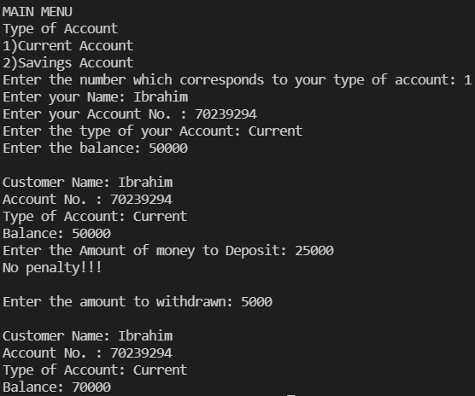

* **For Savings**

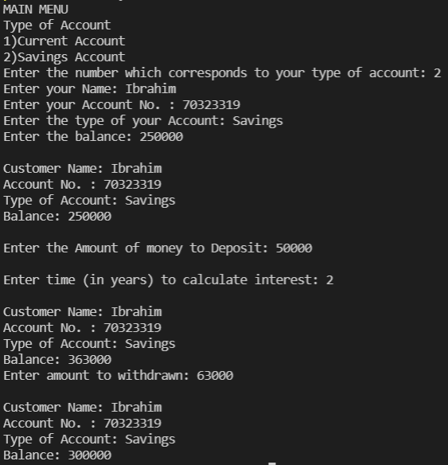

**Output for Problem Statement 2**

* **Teacher**

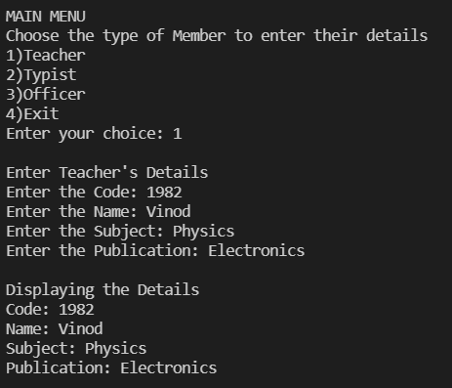

* **Typist**

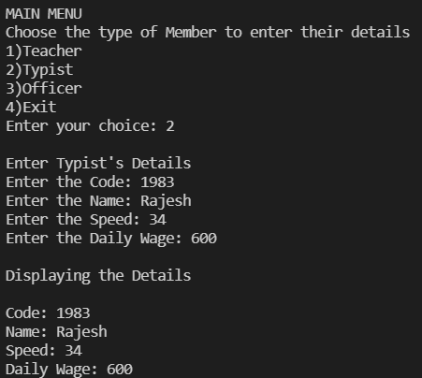

* **Officer**

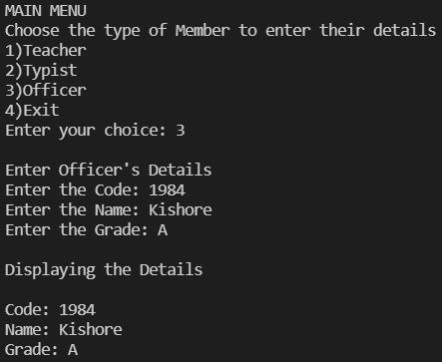

* **Exit**

